**LEASE MANAGEMENT**

**College Name:** **Kumaraguru College of Liberal Arts and Science**

**College Code:** **BRUAX**

**TEAM ID:** **NM2025TMID25559**

**TEAM MEMBERS:4**

**Team LeaderName:** **VISHWAS V B**

**Email:** **vishwas.23bds@kclas.ac.in**

**Team Member1: NETHRA DEVI**

**Email:** **nethraprabu11@gmail.com**

**Team Member:** **SUBHA HARINI J**

**Email:** **subhaharini.23bds@kclas.ac.in**

**Team Member:  P VARUN**

**Email:** **varun.23bds@kclas.ac.in**

# **INTRODUCTION**

## **Project Overview**

## The Lease Management System is a Salesforce-powered solution designed to simplify and optimize the complete process of managing real estate leases. It enables organizations to efficiently manage tenant details, lease contracts, payment tracking, and continuous communication within a single unified platform. By utilizing automation tools such as flows, approval workflows, and email notifications, the system minimizes manual tasks, accelerates operations, and enhances overall productivity.

## **Purpose**

The aim of this project is to equip organizations with a dependable and efficient solution for managing their properties, tenants, and lease-related operations. By reducing manual work and maintaining accurate, real-time data, the system strengthens compliance, improves communication, and allows teams to concentrate on delivering a smooth and effective experience for both tenants and stakeholders.

# **DEVELOPMENT PHASE**

### Creating Developer Account:

By using this URL **-** [**https://www.salesforce.com/form/developer-signup/?d=pb**](https://www.salesforce.com/form/developer-signup/?d=pb)

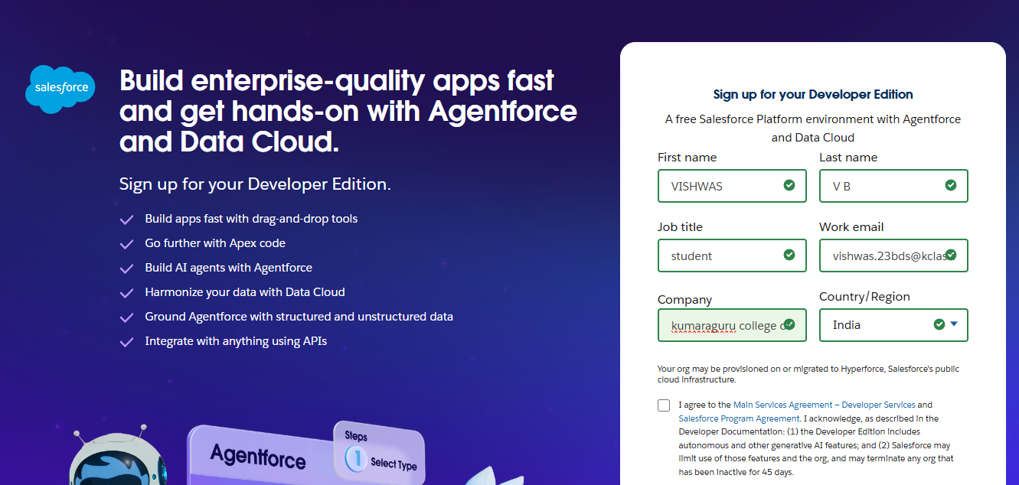

* 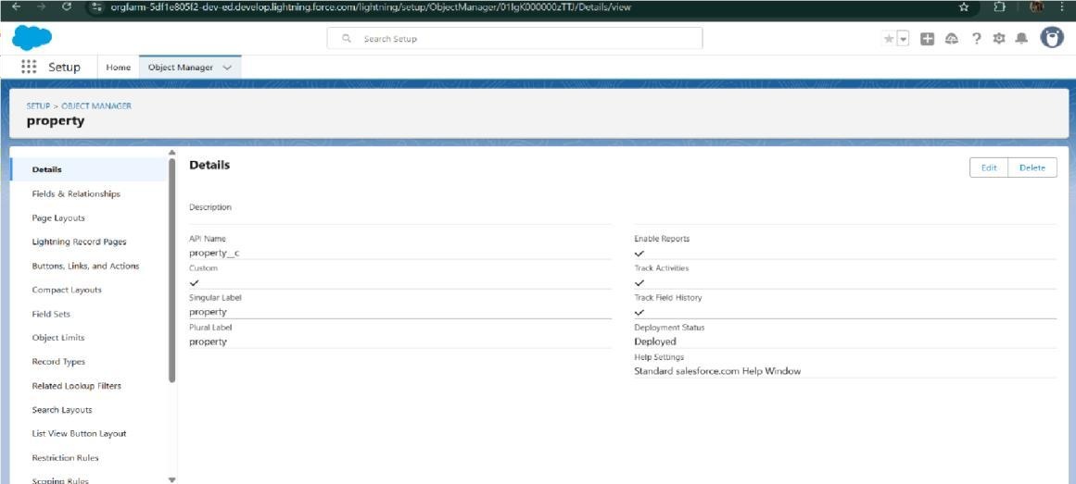Created objects: Property, Tenant, Lease, Payment

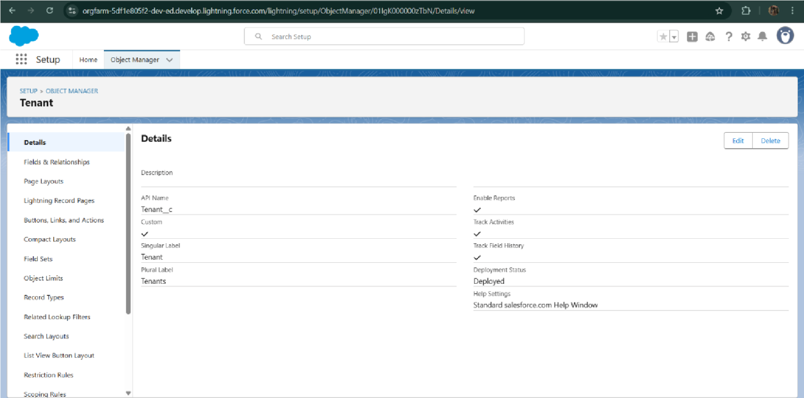

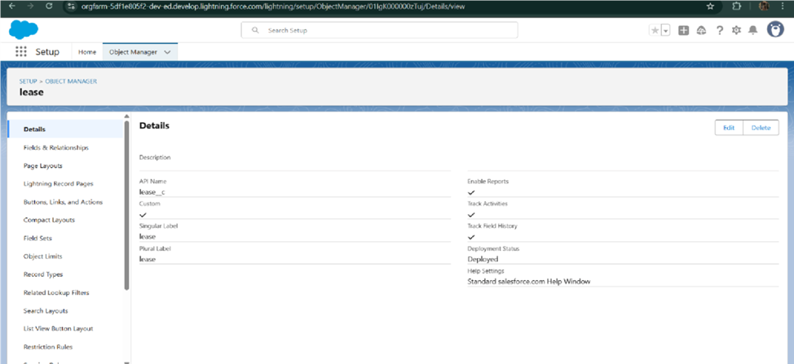

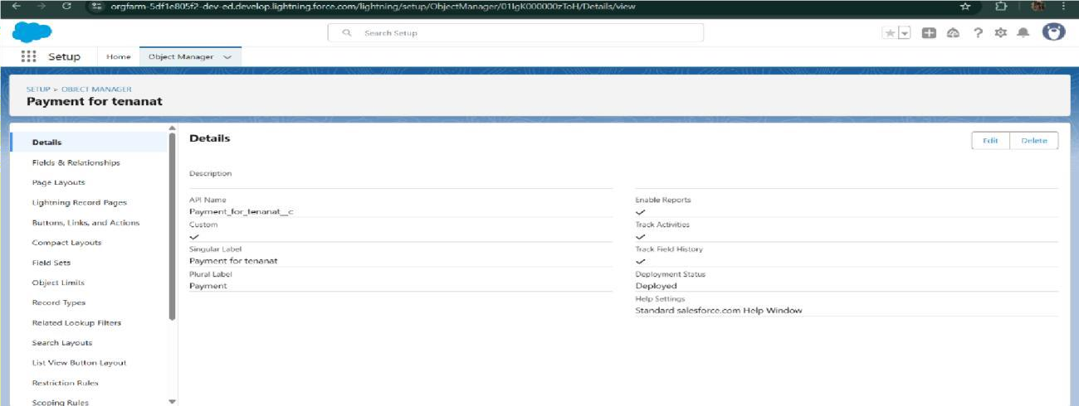

* + - Configured fields and relationships

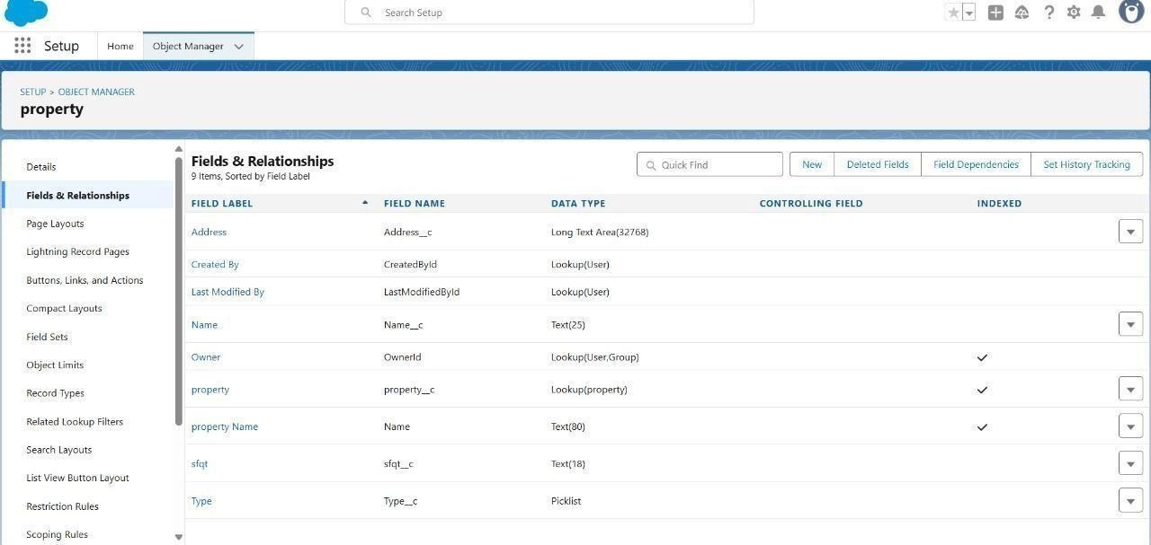

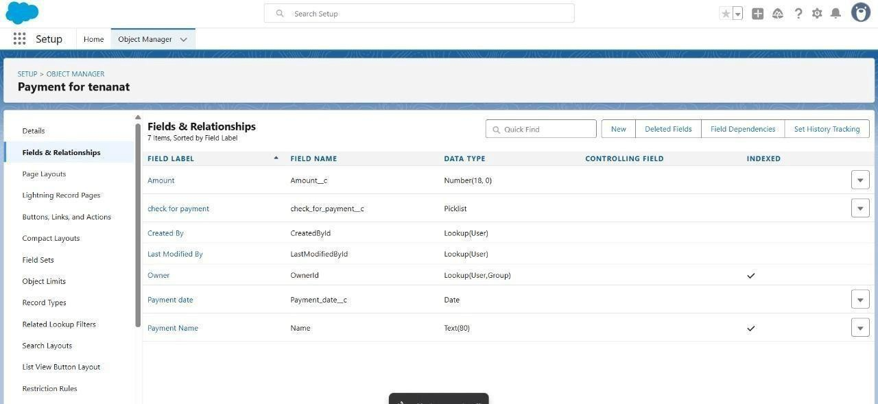

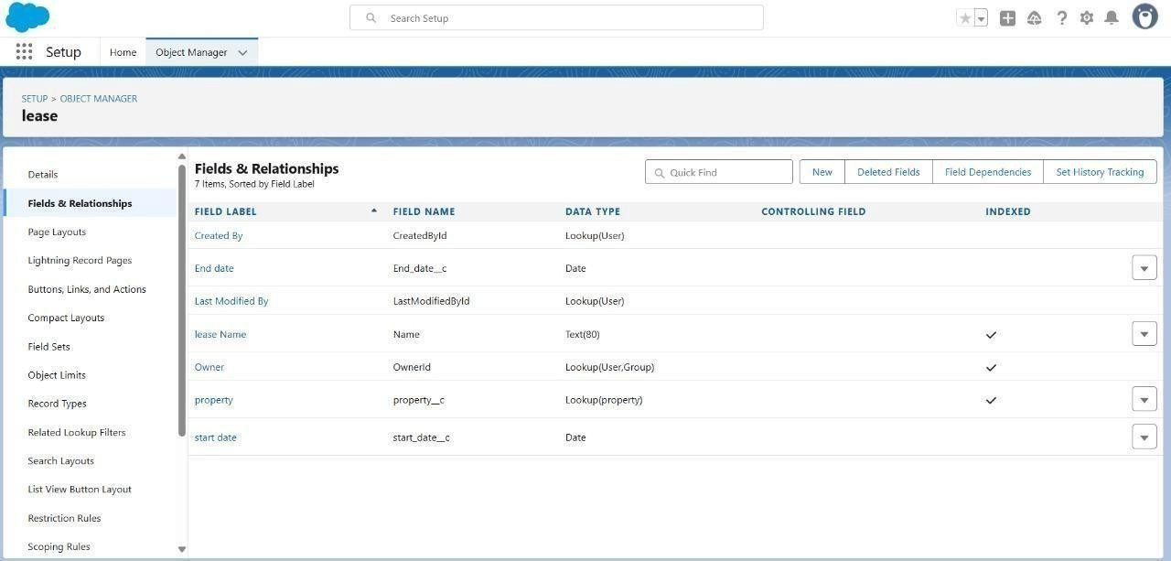

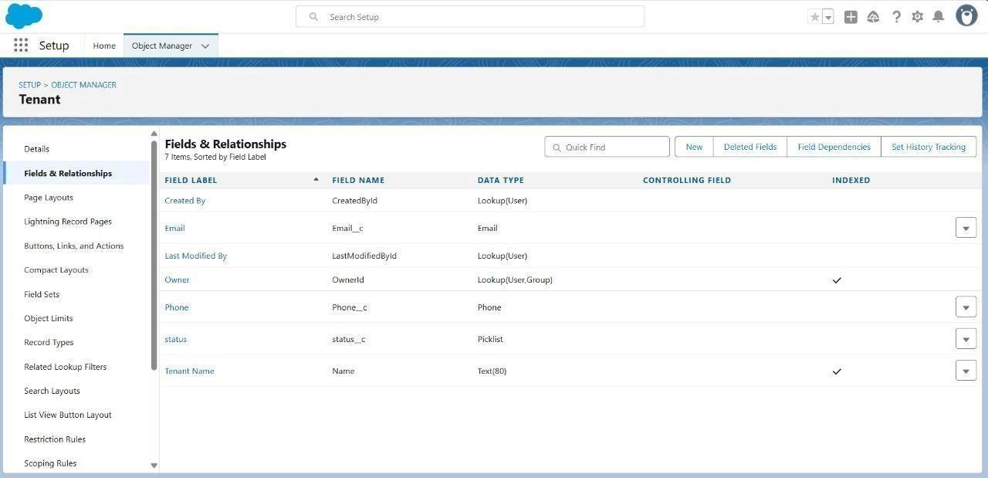

* Developed Lightning App with relevant tabs

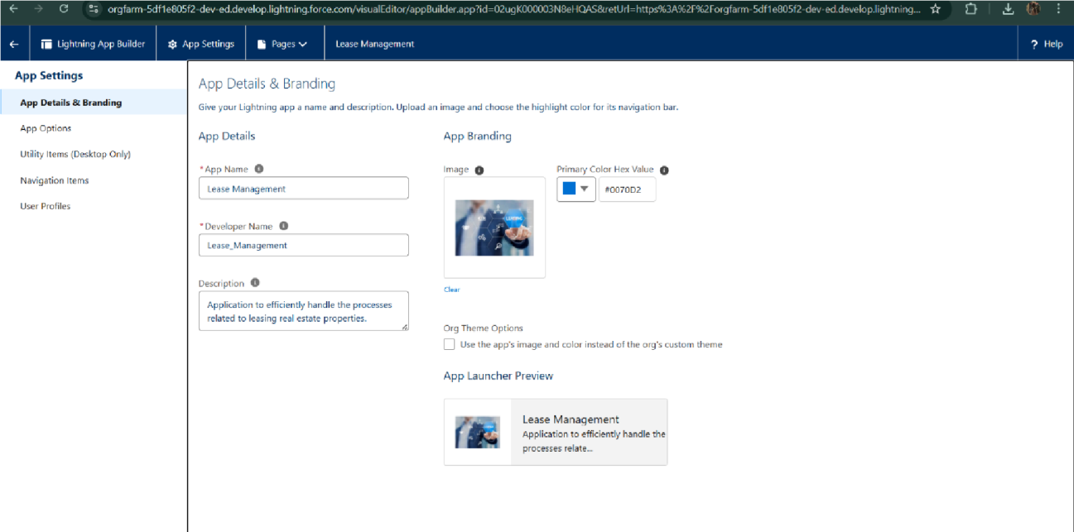

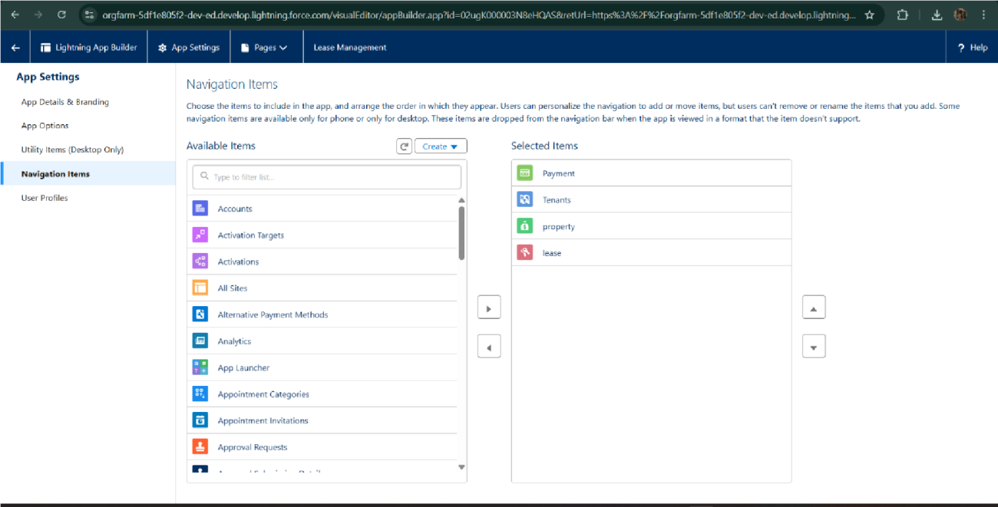

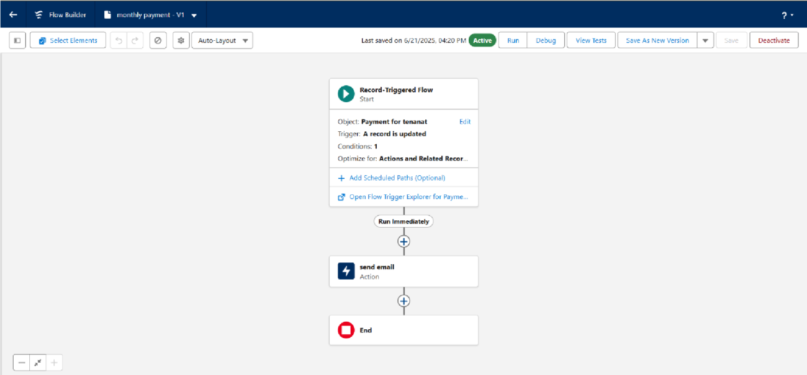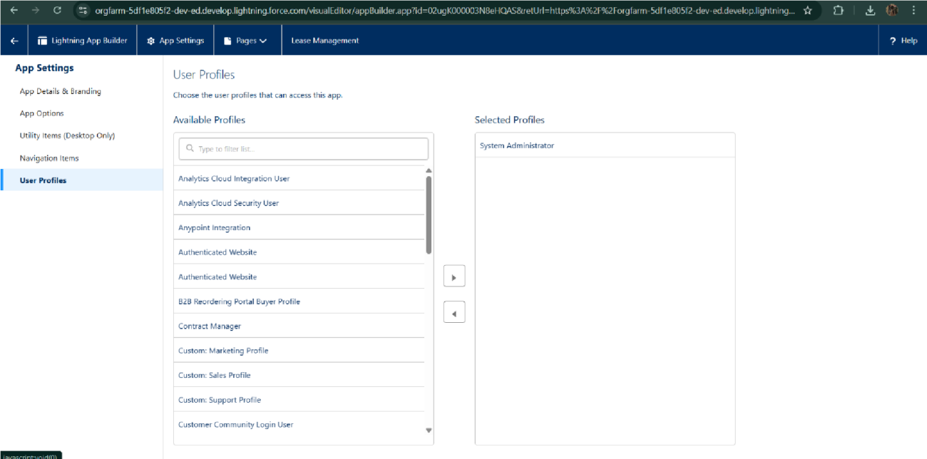

## Implemented Flows for monthly rent and payment success



* + - To create a validation rule to a Lease Object

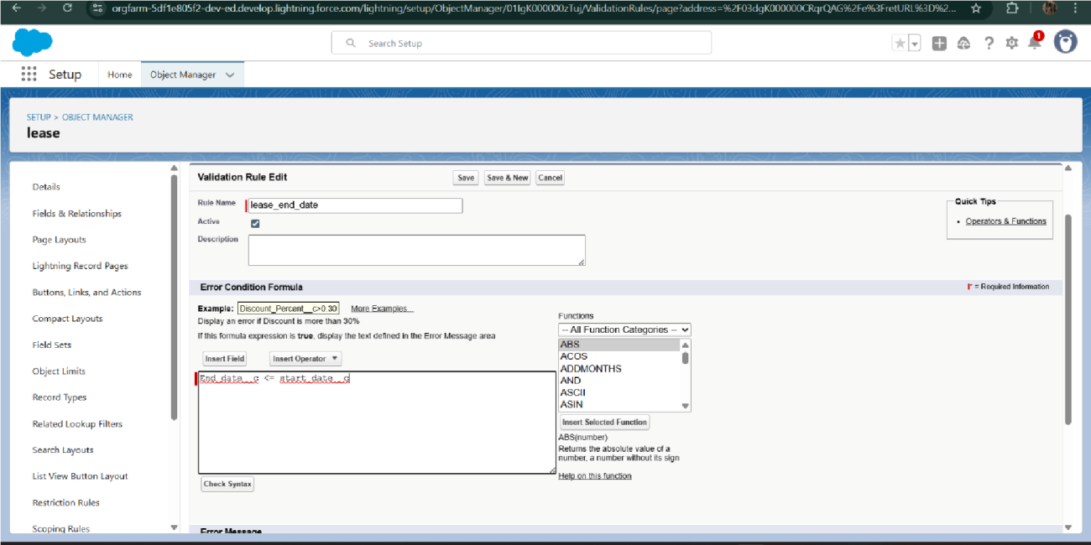

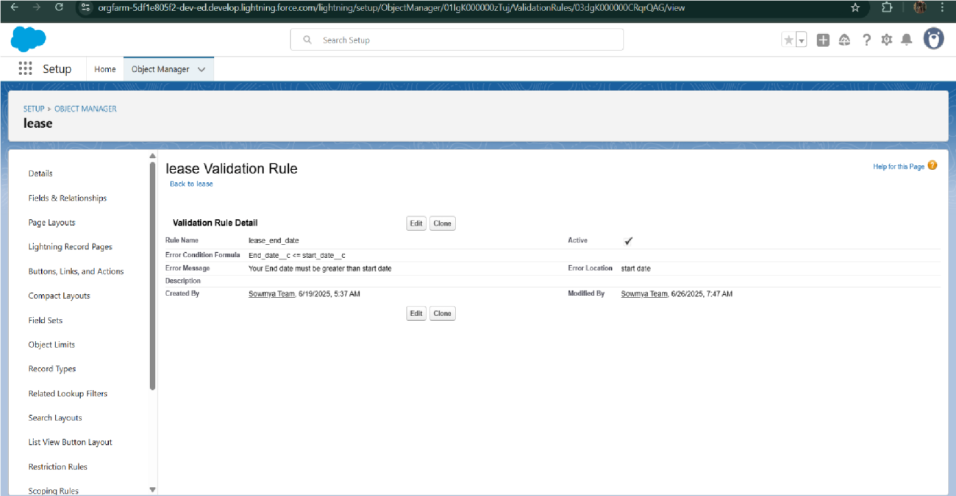

* + - Added Apex trigger to restrict multiple tenants per property

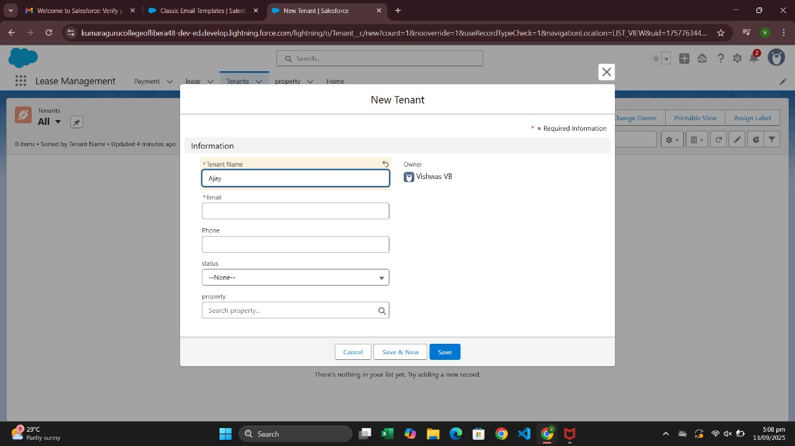

* + - Scheduled monthly reminder emails using Apex class

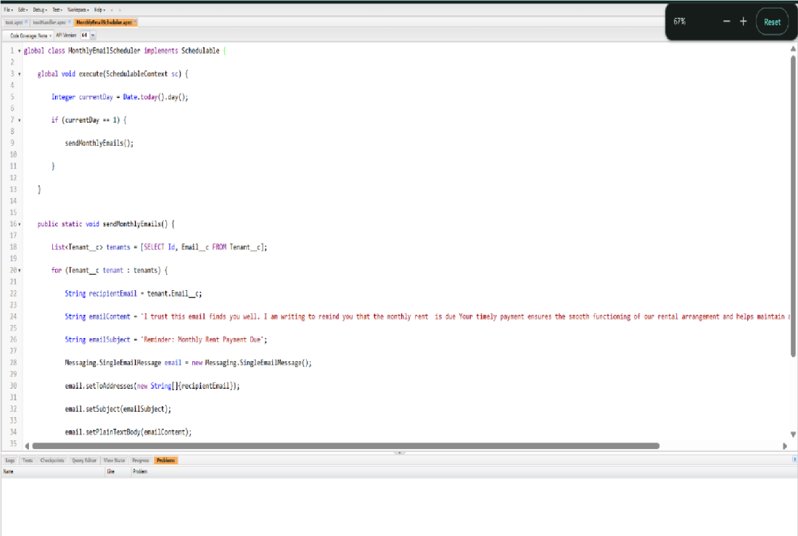

* + - Built and tested email templates for leave request, approval, rejection, payment, and reminders

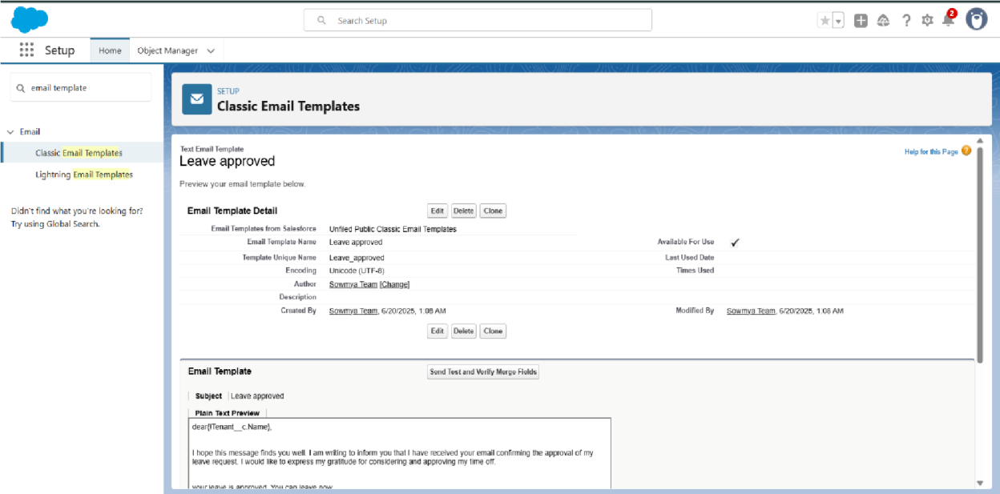

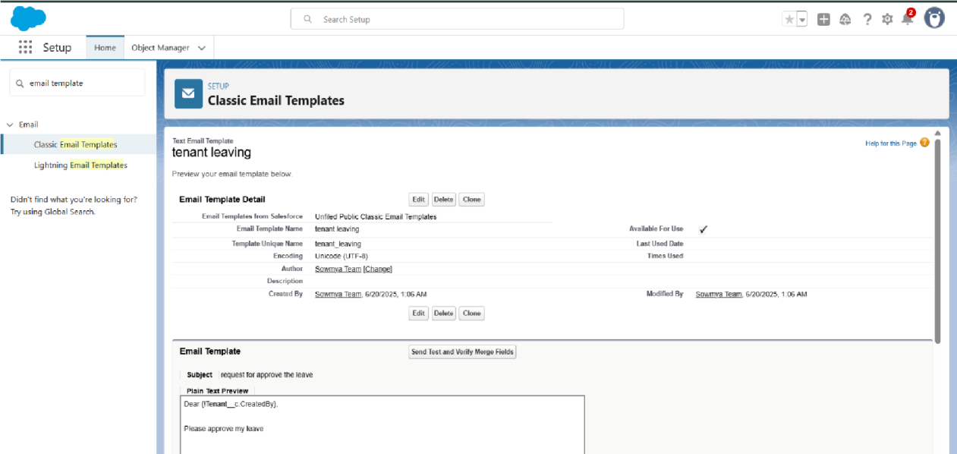

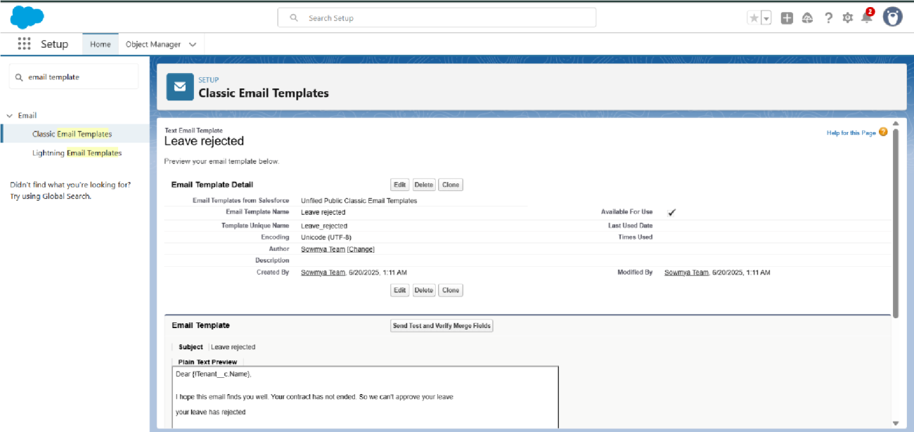

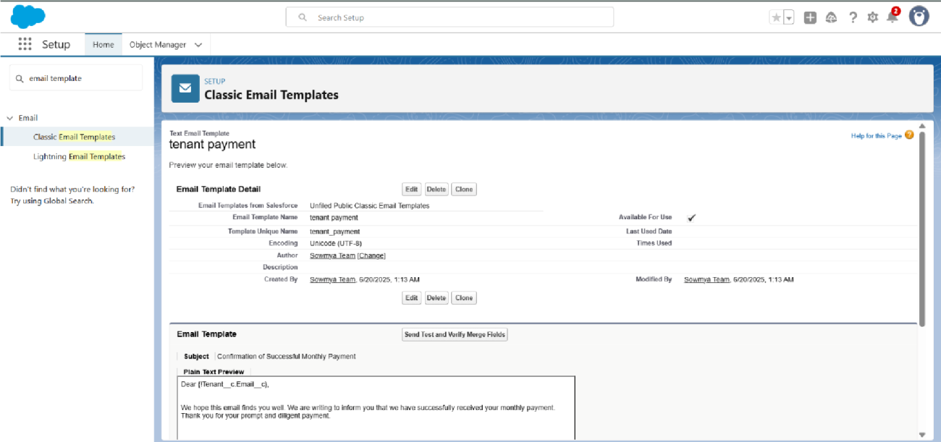

* + - Approval Process creation

For Tenant Leaving:

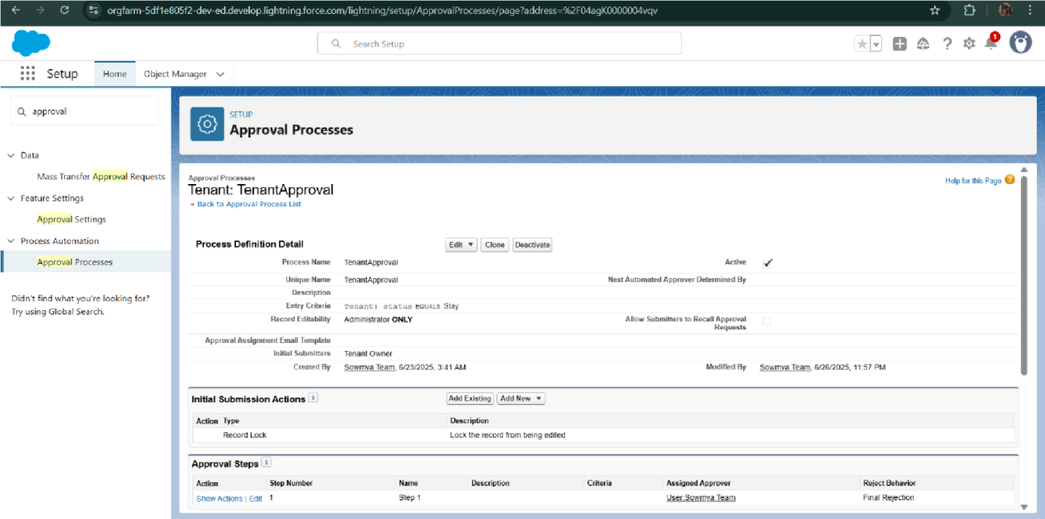

* For Check for Vacant:

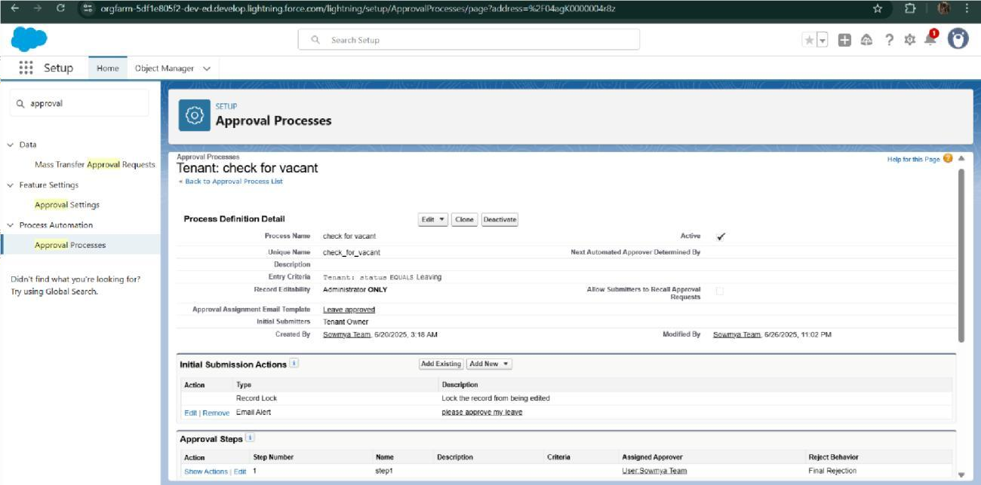

* + - Apex Trigger

Create an Apex Trigger

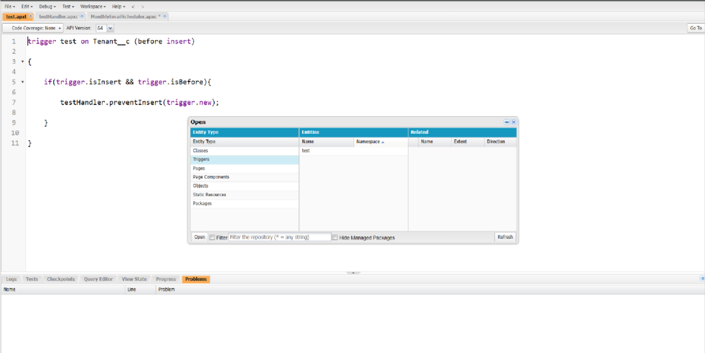

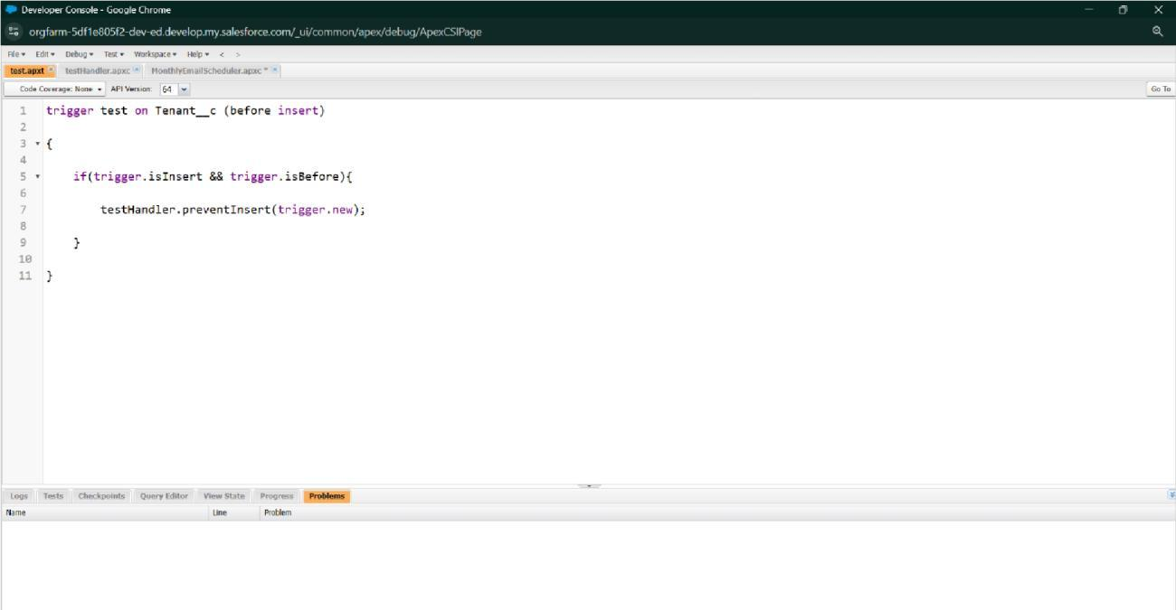

Create an Apex Handler class

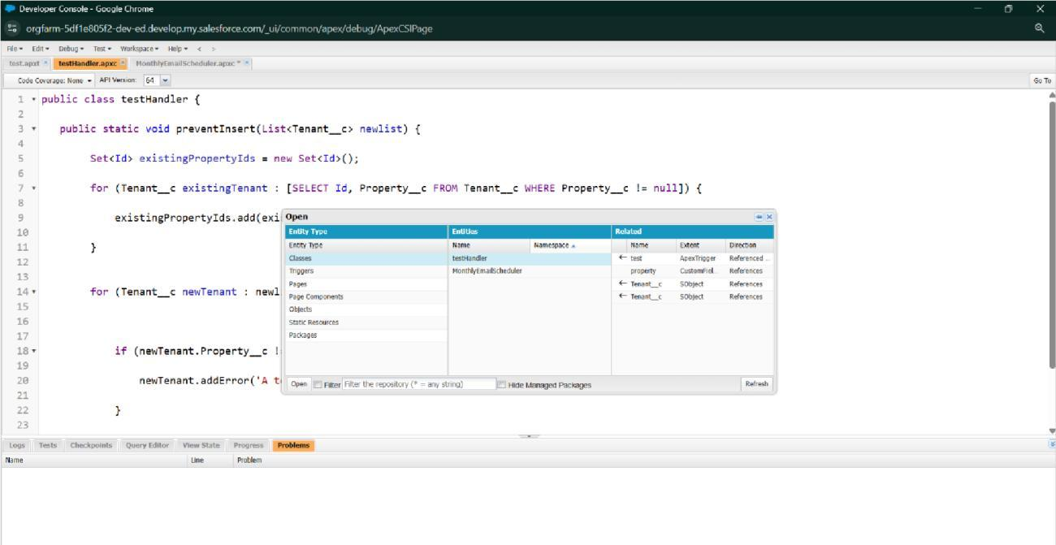

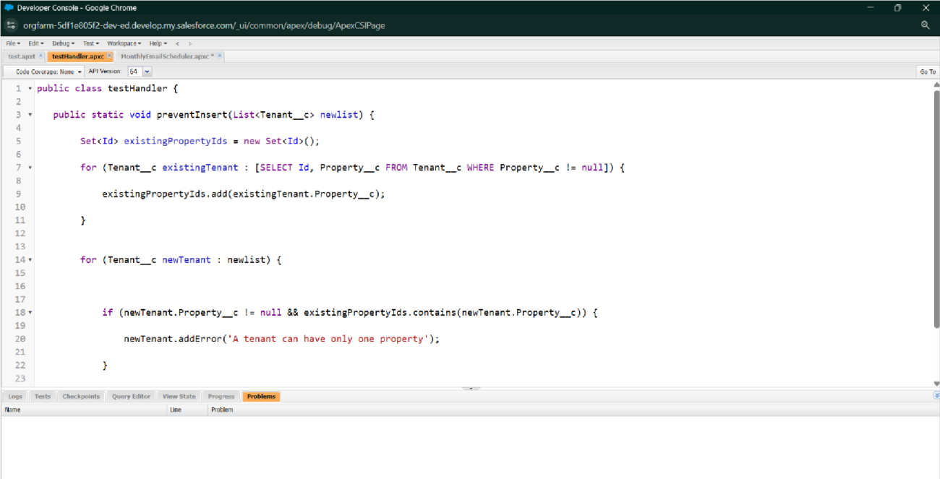

* + - FLOWS

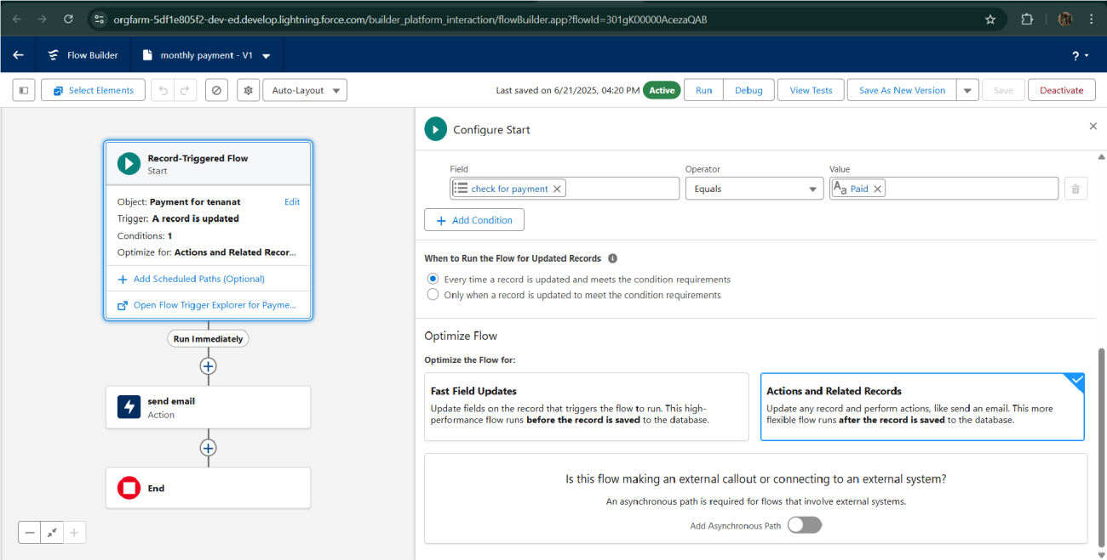

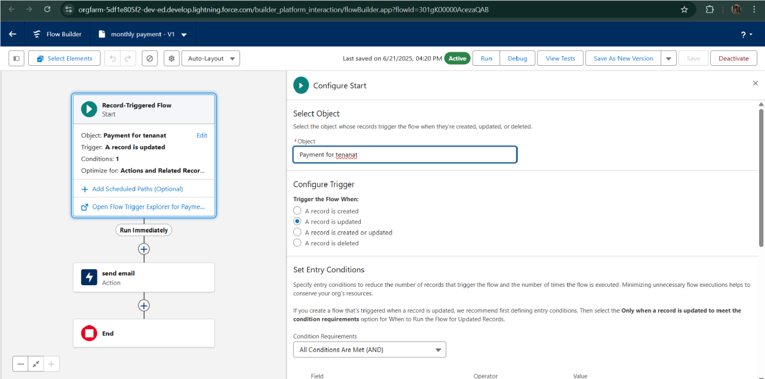

* Schedule class:

Create an Apex Class

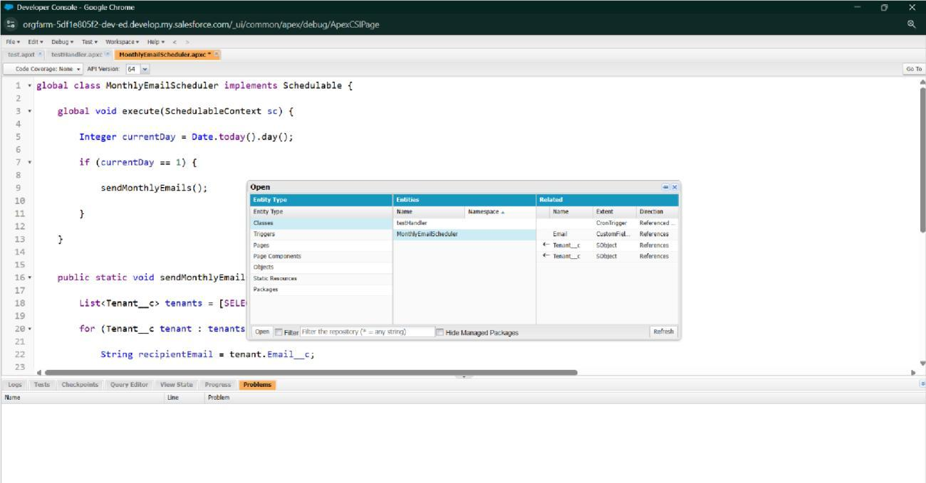

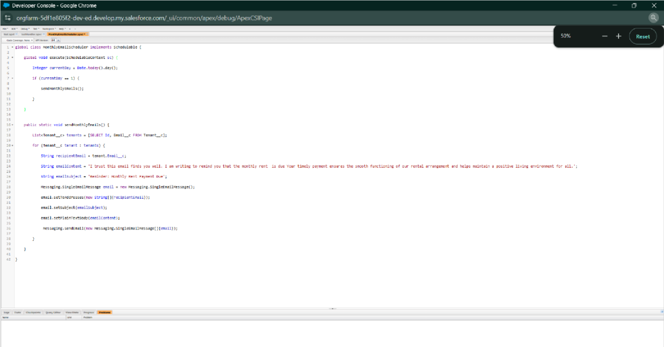

Schedule Apex class

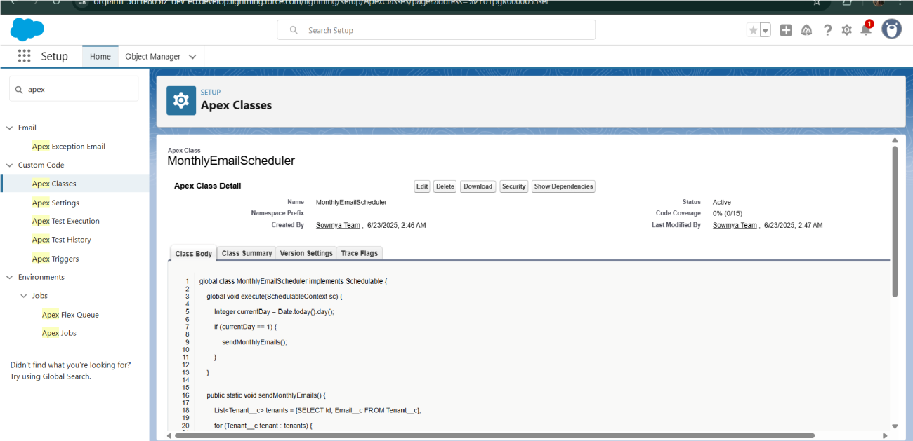

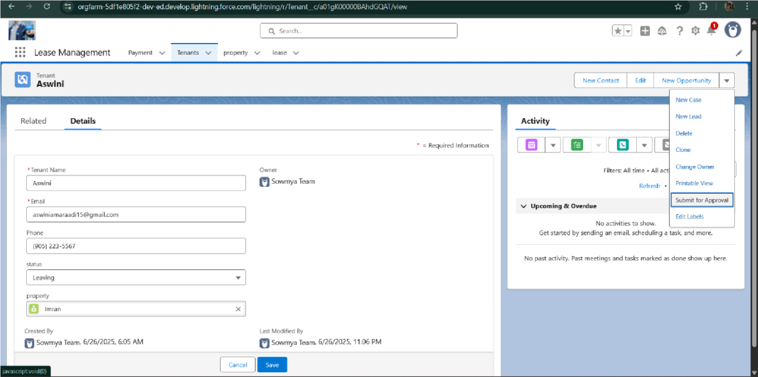

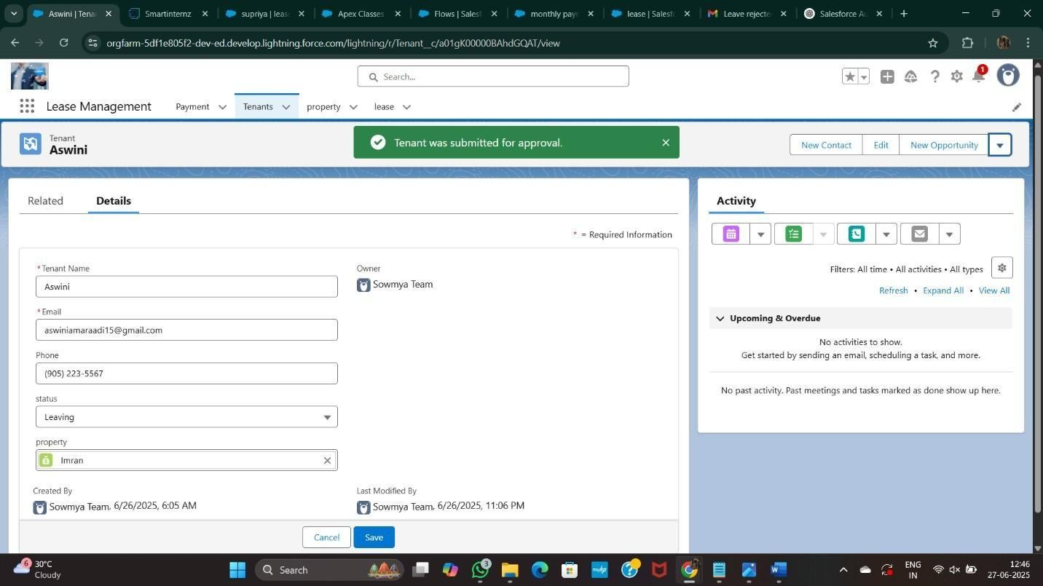

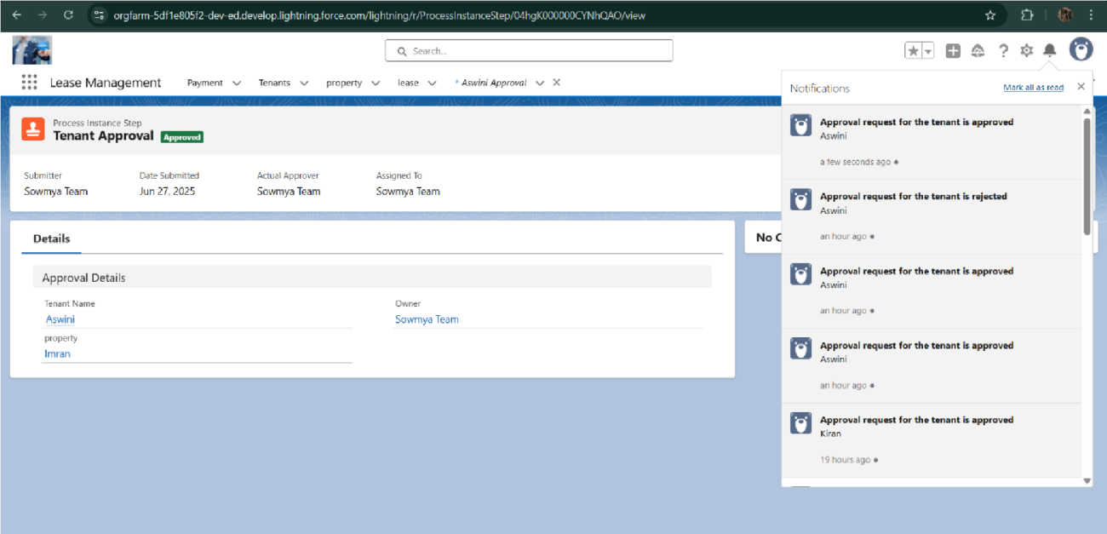

# **FUNCTIONAL AND PERFORMANCE TESTING**

## **Performance Testing**

* + - Trigger validation by entering duplicate tenant-property records

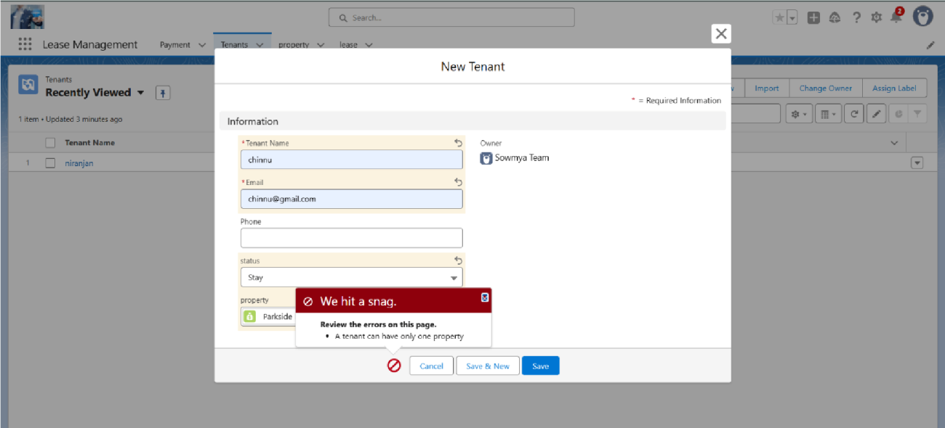

* + - Validation Rule checking

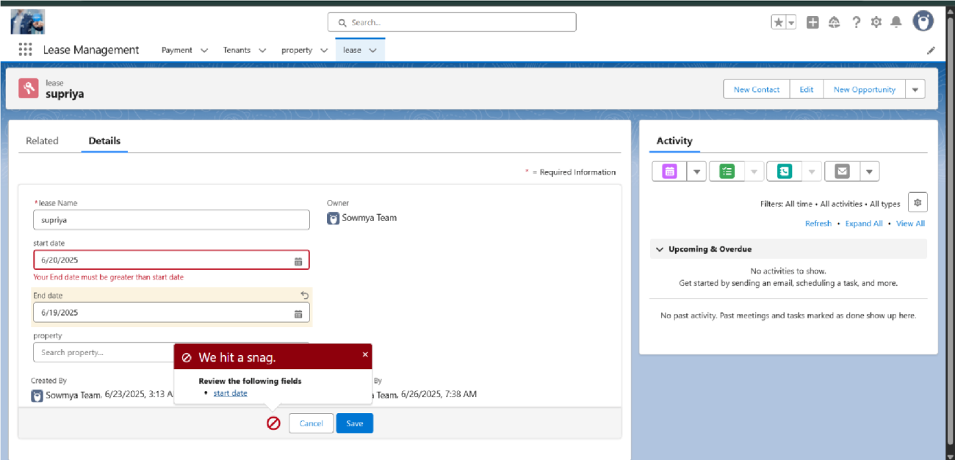

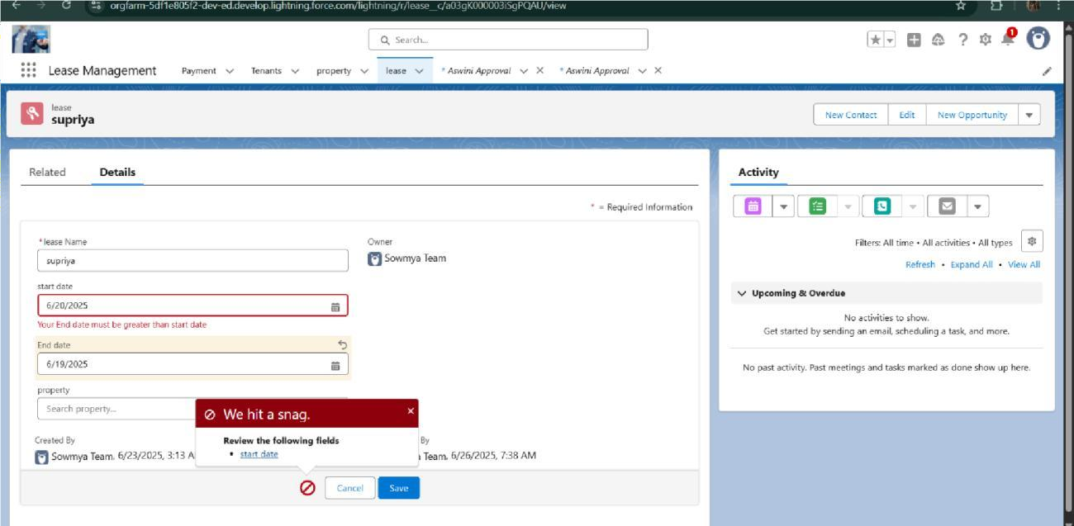

* + - Test flows on payment update

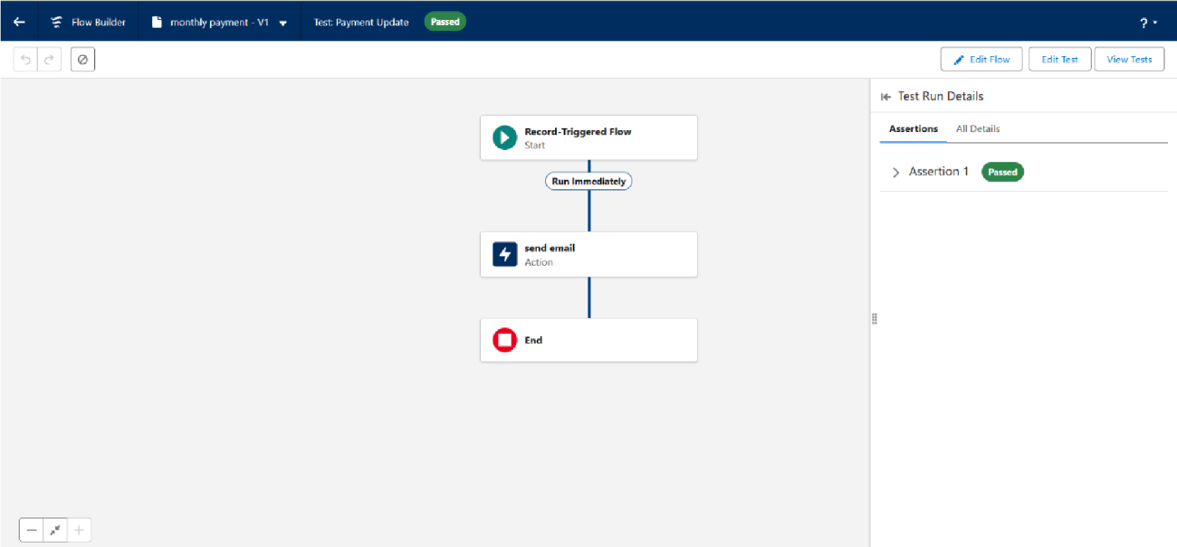

* + - Approval process validated through email alerts and status updates

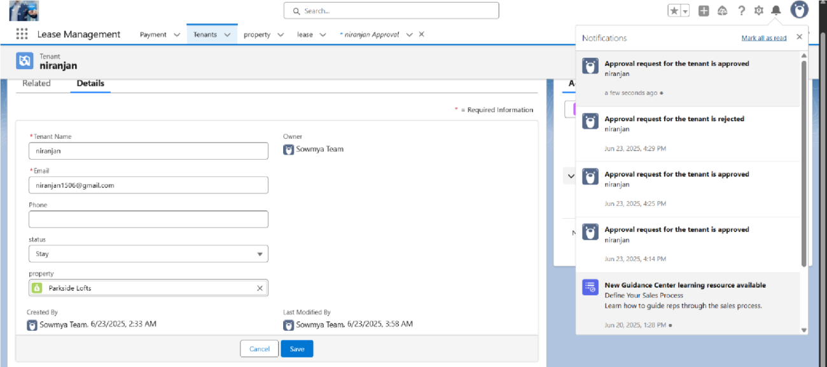

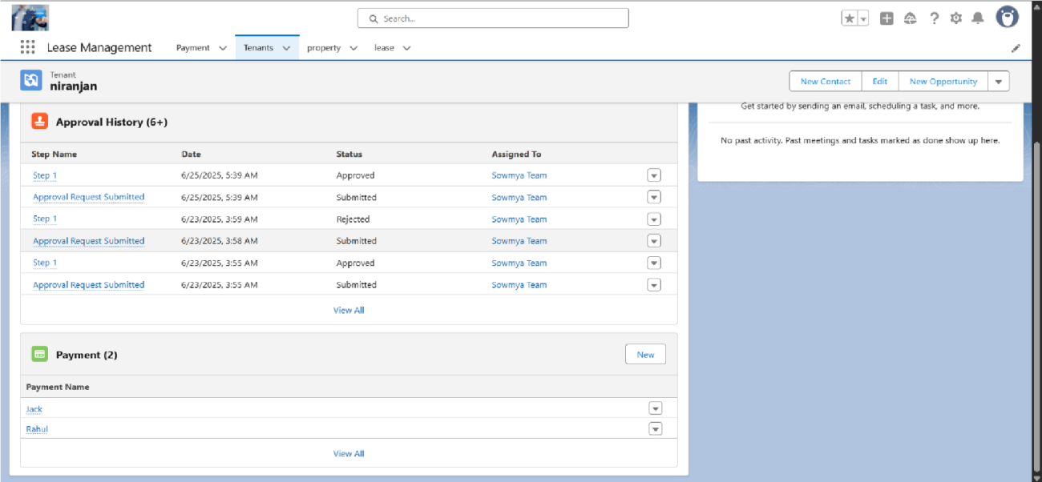

# RESULTS

## Output Screenshots

* Tabs for Property, Tenant, Lease, Payment

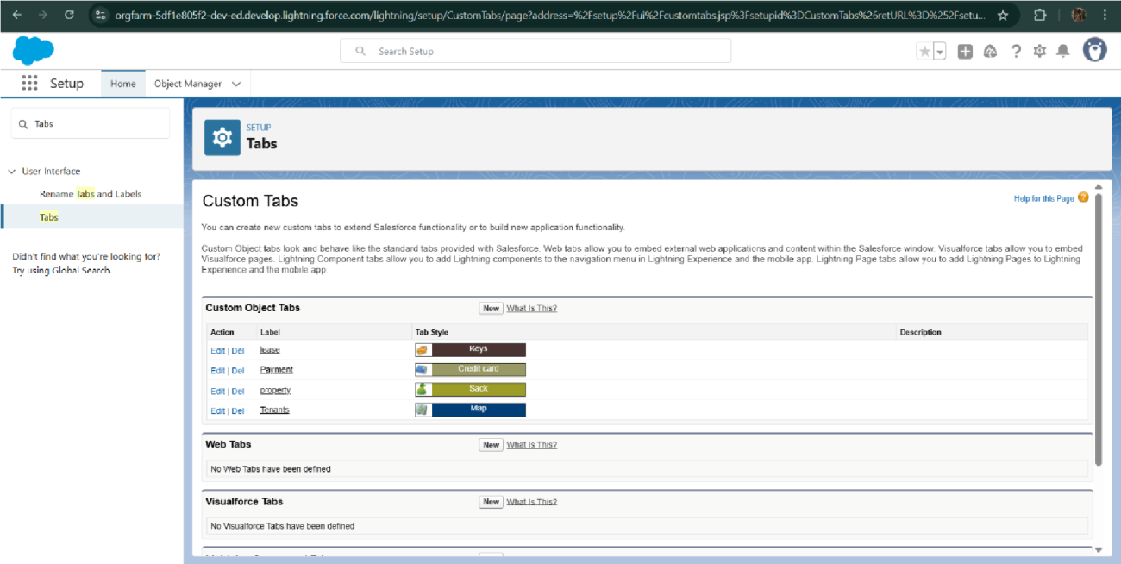

* Email alerts

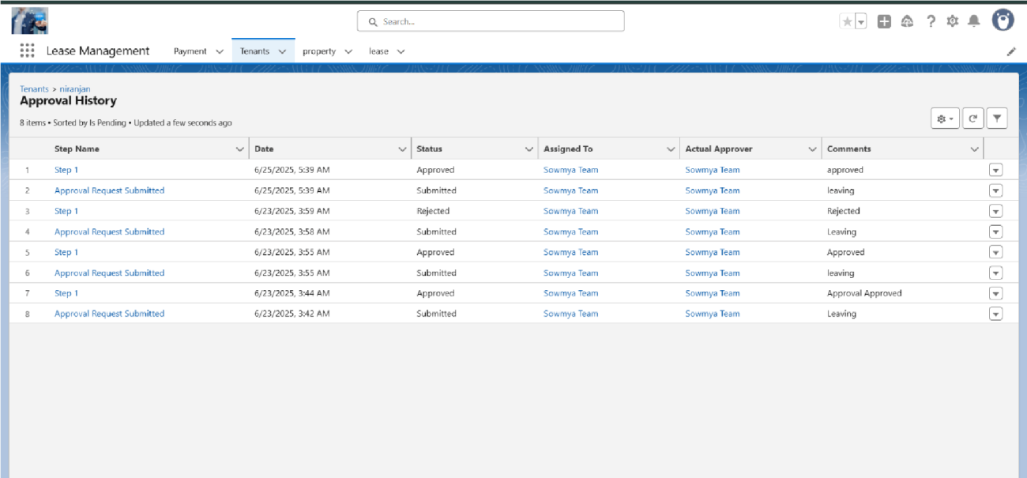

* Request for approve the leave
* Flow runs

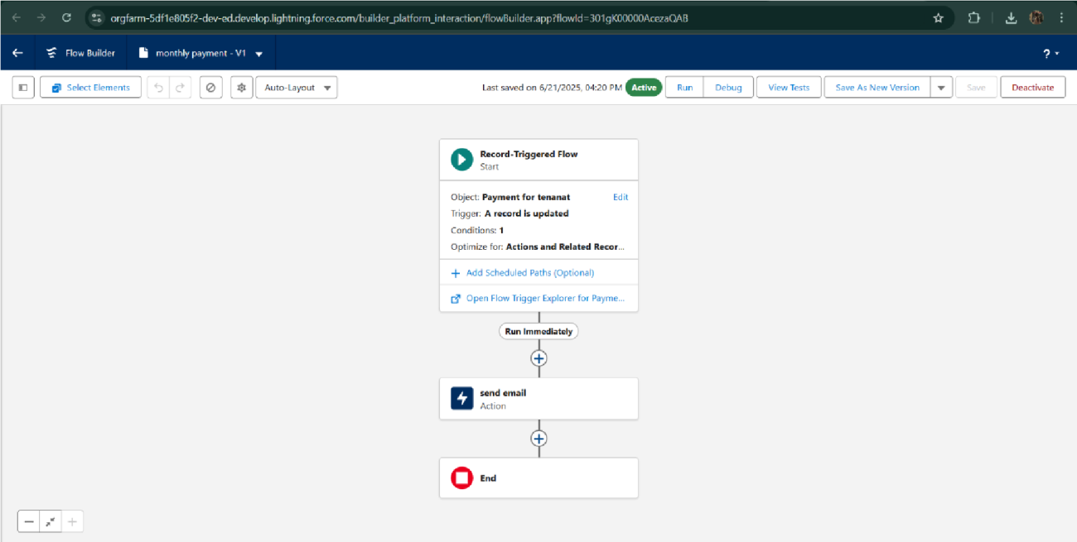

* Trigger error messages

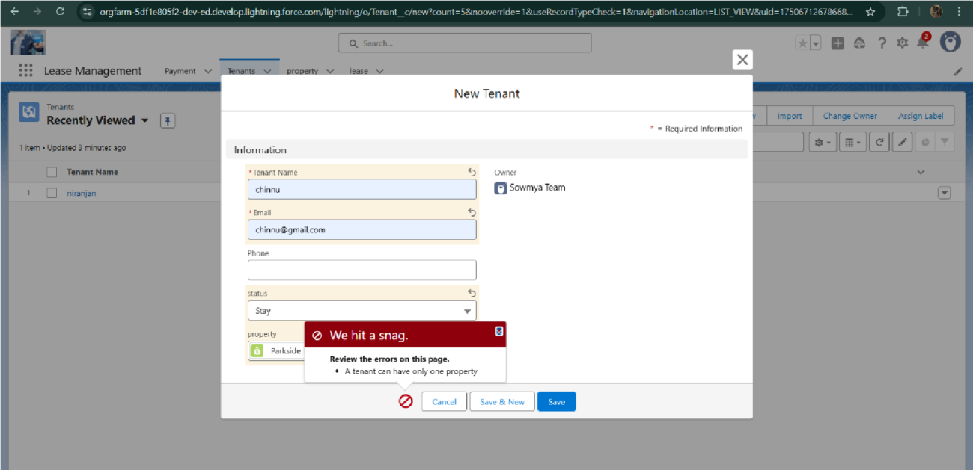

* Approval process notifications

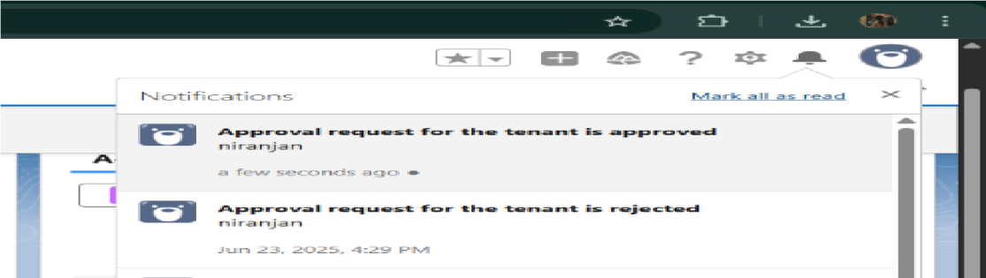

# **ADVANTAGES & DISADVANTAGES**

**Advantages**

* **Centralized Management** – Consolidates property, tenant, lease, and payment details into a single platform, minimizing duplication and errors.
* **Process Automation** – Streamlines approvals, reminders, and notifications, saving time and reducing manual workload.
* **Improved Decision-Making** – Delivers real-time reports and dashboards for effective tracking of leases, payments, and occupancy status.

**Disadvantages**

* **High Initial Investment** – Involves costs for Salesforce licensing, customization, and user training.
* **Learning Curve** – Users may require time and guidance to become fully familiar with the system’s capabilities.
* **Internet Dependence** – As a cloud-based solution, it needs stable internet connectivity for smooth and uninterrupted access.

# CONCLUSION

The Lease Management System effectively streamlines leasing operations by leveraging a structured and automated Salesforce application. It enhances efficiency, ensures accurate data management, and fosters better communication between administrators and tenants.

## APPENDIX

* + **Source Code:** Provided in Apex Classes and Triggers

### Test.apxt:

trigger test on Tenant c (before insert) { if (trigger.isInsert && trigger.isBefore){ testHandler.preventInsert(trigger.new);

} }

### testHandler.apxc:

public class

testHandler {

public static void

preventInsert(List<

Tenant c> newlist)

{ Set

existingPropertyIds

= new Set()

for (Tenant c existingTenant : [SELECT Id, Property c FROM Tenant c WHERE Property c != null]) {

existingPropertyIds.add(existingTenant.Property c;

} for (Tenant c newTenant :

newlist) {

if (newTenant.Property c != null && existingPropertyIds.contains(newTenant.Property c)) { newTenant.addError('A tenant can have only one property');

}

}

}

}

MothlyEmailScheduler.apxc:

global class MonthlyEmailScheduler implements Schedulable {

global void execute(SchedulableContext sc) { Integer

currentDay = Date.today().day(); if (currentDay == 1) {

sendMonthlyEmails();

}

} public static void

sendMonthlyEmails() { List

tenants = [SELECT Id, Email c FROM

Tenant c]; for (Tenant c tenant :

tenants) {

String recipientEmail = tenant.Email c; String emailContent = 'I trust this email finds you well. I am writing to remind you that the monthly rent is due Your timely payment ensures the smooth functioning of our rental arrangement and helps maintain a positive living environment for all.';

String emailSubject = 'Reminder: Monthly Rent Payment Due';

Messaging.SingleEmailMessage email = new

Messaging.SingleEmailMessage(); email.setToAddresses(new String[]{recipientEmail}); email.setSubject(emailSubject); email.setPlainTextBody(emailContent); Messaging.sendEmail(new Messaging.SingleEmailMessage[]{email});

}

}

}